When is the power really on?
Elizabeth Shove, 6.1.16
The prolonged power cuts in Lancaster in December 2015, and efforts to cope with them, highlighted a number of usually invisible questions about how electricity is known and used.
On the face of it, it is pretty obvious when the electricity supply is off: no lights come on, nothing works. However, experiences of the power cut, or to be more precise, of the ensuing power shortage showed that the status of ‘on’ and ‘off’ is much more ambiguous. After Lancaster’s sub-station was flooded, somewhere between 60 and 80 emergency generators were delivered to the town. When these were installed and connected, the power ostensibly came back on and electrical equipment functioned, just as it did before. But not quite: although not obvious at the point of use, the power that was ‘restored’ was provisional – it was not ‘real’ power, as we have come to know it. It was not ‘real’ in the sense that it was not unlimited: there was only so much the imported generators could produce, and this was very much less than the seemingly infinite supply of mains power routinely provided from the grid.
Electricity NW provided advice about being ‘sensible’ with this not-quite-normal power.
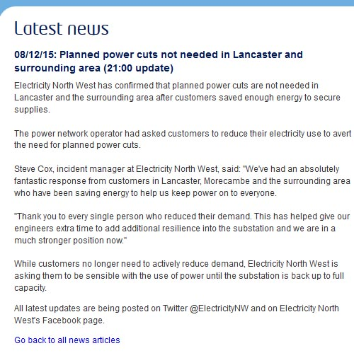
Of course by ‘saving’ Electricity NW actually meant ‘not using’ electricity, even though the power was ‘on’. At some scale, items that could have been powered were not (they were sensibly turned ‘off’ despite potentially being ‘on’). Indeed it was precisely this restraint which allowed the power to be ‘on’ to ‘everyone’.
The advice distinguishes between ‘actively reducing demand’, and being ‘sensible’ until the substation is back to ‘full’ capacity – after which, presumably, infinite or even profligate consumption is possible. By implication, and for a short while, there are grades and shades of ‘off’ and ‘on’ to be taken into account. Alongside this, there is the clear goal of restoring the capacity for anything and perhaps everything, to be always ‘on’. This is a normal understanding of what electricity supply is about. It is also misleading. At some level, power is always limited, and is always rationed and distributed - it is just that this feature doesn’t often come into view, not in the UK.
In Lancaster, dealing with situations not of absolute power cut but of limited power highlighted matters of allocation that are now so thoroughly unfamiliar as to be almost incomprehensible – and certainly difficult to explain.
During the period of Lancaster’s limited power (provided by imported generators), the University – as a major (single) consumer – was rationed to around a fifth of its ‘normal’ supply. Alongside this ‘unreal’ utility-generated power the University had some generators of its own. But together these fell well short of meeting normal demand. Some buildings were therefore closed and the potential to use power was deliberately, and necessarily, restricted. Other buildings functioned as ‘normal’.
Some people found this puzzling. The official advice was for non-essential staff to stay at home but in certain places there was heat, light, and power. .. If the electricity was there, and could be on, why should staff go home? In the absence of any clear account of what ‘restricted power’ really means, or what constitutes ‘normal’ operations it was hard to figure out what it meant to ‘have’ power, or not. The normal test of trying a switch was clearly not enough.
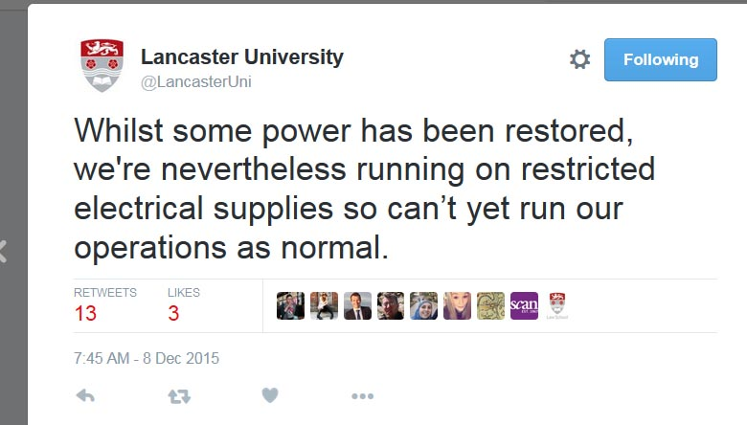
Was the power on, or was it not? It was extremely difficult to tell. For a start, telling depended on distinguishing between different forms and blends of power: usually we only think of one. Within Lancaster, there were at least two varieties: that which was locally generated and that which came – at a certain point - from the grid, the relative proportions of which shifted over time. As noted above the source is unclear at the point of use, a feature that prompted discussion about the type of power on offer.

Extract from Noel Cass’ account:
“Please could we ask that those restored by generator in #‎Lancaster‬ keep their usage to a minimum & only use appliances where necessary.” (ENW Electricity North West 8 December at 11:44)‬‬‬
People reasonably asked whether or not they were on a generator supply, and therefore needed to reduce consumption:
“David Kitchen How do we know if we are the ones restored by generator??· 8 December at 12:18
Electricity North West We are using both generation and mains supply currently to try and stabalise the grid until full repairs are made.8 December at 15:31

On campus there were three forms of power: that provided by the university’s own generators – which ‘worked’ even when Lancaster was down; power provided by the utilities’ generators; and potentially and in some combination, ‘real’ power from grid.

Whether the power was ‘on’ or not was also a matter of perspective.
When Electricity NW ‘restored’ its power supply to the university, it announced this in the tweet copied below.
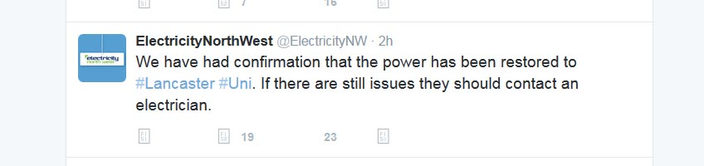
Tweet from around 8.30pm on 8th December
At this point, and in order for the University or indeed much of Lancaster to be ‘on’ at all (in any sense), most of the campus had to be ‘off’ since the University was radically restricted in how much power it could use. In this context, the black and white terminology of ‘restoring’ power caused extensive confusion. For example, students who were unable to occupy their residences, which were deliberately turned ‘off’ because power was so limited, were able to see that other homes in Lancaster were ‘on’. They also learned from the tweet (above) that power had been ‘restored’ to the university, much of which was still shut down.
There was a rapid correction:
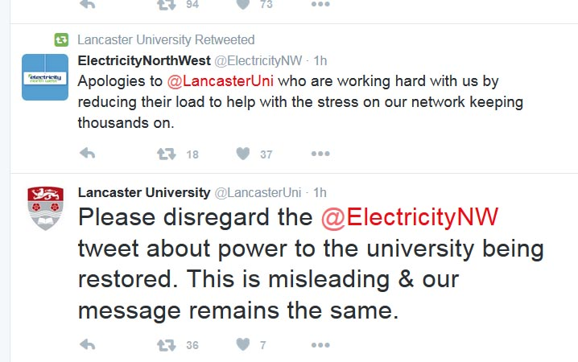

Tweet from around 9.30pm Tuesday 8th December 2015
But it was too late. It looked like someone was ‘choosing’ to take power off. And it looked like the students were now being disadvantaged. From this point of view, the meaning and the balance of having and not-having power had swung round. Initially – and when Lancaster was really off, it was the University, with its own generators, that was ‘on, at least in part, when most others were without power. But when power was ‘restored’ it was so in such a restricted sense that it was not really available, not on the scale that the concept of ‘restoring’ would suggest. Explanations were called for:
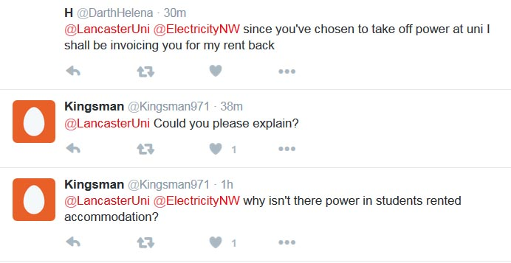
Tweet from around 9.30pm, 8th December 2015.
Perhaps because the situation was so fluid, and the issues so complicated – just how much power does the university need, what are its priorities, how are these negotiated? – or because there was so much else going on, there was no concerted attempt to explain. As it happens, the move from partial to ‘full’ restoration was relatively quick and by Wednesday the University was reporting as follows:
“Electricity North West has confirmed that power can be fully restored to campus and we are working to switch all buildings on and return to safe operations. While this is going on we are asking staff who aren’t involved in graduation or who haven’t been called in, to stay at home today.” (Tweet)
Another surprise was the difference between the phrase ‘can be fully restored’ and ‘is fully restored. As many people learned, going back ‘on’ was a sequential process, not something that happened all at once or at the flick of a single switch. Even when power is formally restored, it may still not be safe to occupy a building in that it takes three hours to recharge emergency light batteries and fire alarms, meaning that there are grey areas of interpretation even when grid supplies are fully restored.
Since the University was connected to what looked like, and felt like, and apparently was mains power on Wednesday, it was unaffected by the wholesale return to .. what should we call it? ‘real’ or ‘normal’, ‘mains’ or ‘grid’ power in Lancaster, which took place a few days later.
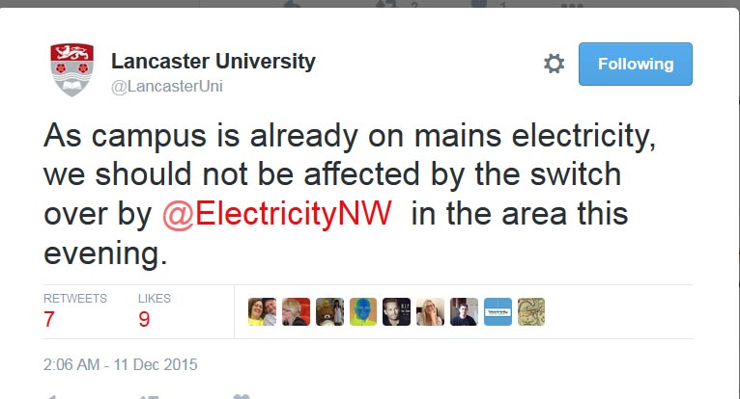

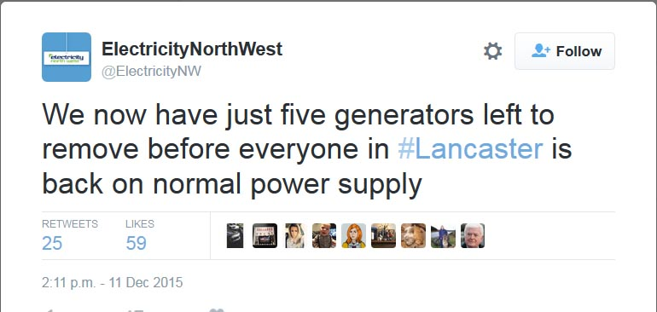

2/12/15 Lancaster customers back on the grid (11:30am update)
Customers in Lancaster and surrounding areas who had been receiving power via generators are now all back on the grid, Electricity North West confirmed today (Saturday, December 12).
More than 70 generators had been providing a temporary power source to 23,000 customers in the area after the River Lune burst its banks and flooded the main substation.
Engineers spent Friday night switching remaining properties back to the power grid, and this work is now complete. (From Electricity North West tweet).

From this point on definitions of power settled back into their seemingly singular and seemingly unambiguous form. But as we now know, and as the power shortages revealed, things are not always what they seem. Power supplies really are multiple, various, mixed and interconnected: they are also always limited, and there are always questions of priority and of distribution and allocation.

