**The pervasiveness of power**

**Elizabeth Shove, 8.1.16 –**drawing on notes from Noel Cass, Adrian Friday, Allison Hui and Gordon Walker.

It is no surprise to discover that people in the UK have come to depend on a regular and reliable supply of electricity. The ambition of ‘keeping the lights on’ underpins every aspect of government energy policy and experiences of living without power for more than a few hours are now exceptionally rare.

When such situations do arise, as they did in Lancaster in December 2015, they provide some insight into the otherwise invisible extent and character of electrification. Whilst power is available and taken for granted, new uses are generated, new technologies are plugged in, and without notice, new patterns of daily practice take hold. This is not news: for example, David Nye’s (2010) book on blackouts includes descriptions of the very different consequences of power failure in commercial buildings at different point in history. When files are of paper, and typewriters are manual, a power cut means that workers go home at dusk. Now, office work stops as soon as the computers go off.

Not all such developments are so obvious, many go on in the background and some are only revealed (to some people) when the system fails. The power cuts in Lancaster generated many such surprises and sudden realisations.

It is not only the lights that go off. Some of the things that caught people unawares included electrically powered garage doors didn’t open, trapping cars inside,[1] electronic door locking systems defaulted to open (letting anyone in); fire alarms that had only limited battery back-up; meters that display the charging state of PV and other such systems along with all building energy monitoring systems didn’t work – (as Adrian Friday says, some buildings just don’t work without electricity). More broadly, cash machines didn’t function nor did credit card payment systems; traffic lights; petrol pumps; gas central heating systems with electric controls and pumps (See Gordon Walker’s notes), and a full range of communication technologies including wireless and mobile phones (no signal, plus their batteries run out); laptops, tablets, the internet (and the many facilities that affords), and some landline phones as well.

The list alone is revealing, but the more important issue has to do with the interconnection of so many of these arrangements. The internet/communication infrastructure has been layered onto that of electrical power without most people really noticing. As Noel Cass notes, ‘‘disaster response’ was limited by the simultaneous and related removal of ICT data networks *and* electricity to power them’. Having a plan for what to do without electricity is one thing, but planning for no normal communication is another. So what when the two are inextricably linked? And just when did they become so closely connected? Was it last year, or the year before or a decade ago? There is no answer since these are multiple and creeping developments that have effect in concert and at different scales, but that take place and take hold independently.

In Noel’s words ‘the process of practices becoming fossilised and outdated moves more quickly than we might expect, and from the perspective of energy demand, the embedding or insertion of electrical *and* data infrastructures, appliances and devices into ever more micro-practices (e.g. payment as a practice shared (‘dispersed’) across multiple practice fields) is problematic’.

It is not that no one had thought about this before, rather that the realisation of how far, and how penetrating the consequences might be comes to the surface not in the abstract, but in the moment of trying to do something, to get in touch with a friend to let them know you could cook them dinner, to summon colleagues, or to call in people with the expertise needed to help. This is not only a matter of what is ‘on’ or ‘off’: some ‘traditional’ landline phones did work, but there are now fewer of them just as there are fewer public phone boxes. These historical features of provision and depletion created bottlenecks of a scale that were truly impossible to know in advance since they reflect and relate to the detail of exactly who is trying to do what, and when.

Also not surprising, but also suddenly revealed, the pervasiveness of electric power has enabled the undetected departure of previously relevant technologies and the evaporation of relevant forms of knowledge. Not everyone knows how to use a phone box. Actual lists of phone numbers don’t exist, are out of date or hard to find – and in any case why should these be laboriously maintained and stored when you can normally get the latest information on the internet? Everyday practices, and the materials and knowledge associated with them appeared to have shifted below the radar.

In some instances it was easy to snap ‘back’ to a previous regime: to light the fire and to get the candles out or finally find a way of hand-cranking the garage door. It turns out that some homes are quite well equipped with power storage that is independent of the grid. However, total stocks of alternative fuels, of logs, batteries, food, candles, camping gaz, partly charged appliances etc., tanks of hot water were typically unknown and sometimes unknowable individually or at any scale.[2] Compared to the uniformity and ubiquity of electric power, these reserves are also highly differentiated. Candles are good for lighting but not for much else. Different practices were associated with specific resource demands, and were prioritised and rationed accordingly. (See Adrian Friday’s notes on eking out ipad time).

These few observations point to wider issues of substitutability, and power in another sense. Whilst many aspects of daily life have come to depend on powered devices and a reliable electricity supply the nature of this dependence varies from one practice to the next.

For example, certain activities can switched to daylight hours, and there are often multiple ways of keeping warm. However, the scope spatial/temporal flexibility is limited, practice by practice, and from one situation to another. In addition, there are some things that cannot be worked around: for example, individuals cannot re-make the internet alone, and they are literally powerless to influence the mobile phone signal – even if they happen to have a wind up battery charger. Whilst substitutes for email, such as handwritten notices, flipcharts and megaphones work, they do so at such a different scale that they are not really substitutes at all.

As Noel notes, the radio was one of ‘the few sources of information due to the relative lack of embeddedness/interlinking of radio and mains electricity’ that was in working order. Of course access to the radio depends on the position both of the transmitter and the receiver (a battery powered, or wind up radio is a must), but for getting hold of some kinds of information, its success and momentary importance was enhanced by the failure of other forms. The power shortage also generated- or perhaps revealed -the significance of twitter. For those with a bit of power and a bit of a signal, it turned out that twitter was all. Forget the websites – for live and regularly updated information, twitter was the answer. It seems that the power cuts led to a significant increase in twitter users.[3]

From the personal accounts we have collected, one of the most powerful feelings of being without power was that of being cut-off from friends/family (see notes from Allison Hui and Adrian Friday), of being out of reach, unable to reach others and not knowing what was going on. Adrian Friday was surely not alone in charging his phone, as a top priority.

The interdependence of electricity and communication is not usually a topic of much concern. But when these systems failed together, a range of technical and organisational questions came into view. It turns out that power is needed not at one point or place, but at multiple sites across the internet/wireless/mobile signal networks/ chains of provision, and related systems of ownership, responsibility and supply. A functioning phone or laptop is required. But power is also needed to some remote, location unknown, site which enables the data to flow. It turns out that all the elements of these multiply interlinked systems need to be in place. As Noel concludes, ‘the implications for energy futures are that communication in (increasingly predictable/prevalent) electricity-free periods should be rethought, and that ICT appliances and devices with multiple forms of powering are more resilient.’ It would be interesting to find out more about what these options might be – and also at what scale they might exist: e.g. could the university have its ‘own’ communication network. The obvious problem with that is that communication is, by definition, with a host of others who also need to be connected.

Nye D. (2010) *When the lights went out : a history of blackouts in America,* Cambridge, MA: MIT Press.

1. There might be some hand operated ‘emergency’ release but for that you’d need to find the manual, and you can’t look it up on line.
2. See Greg Marsden’s work on how much petrol is stored in peoples’ cars at any one time.
3. After the event, Electricity NW has produced some figures about the scale and form of social and other types of media interaction.

   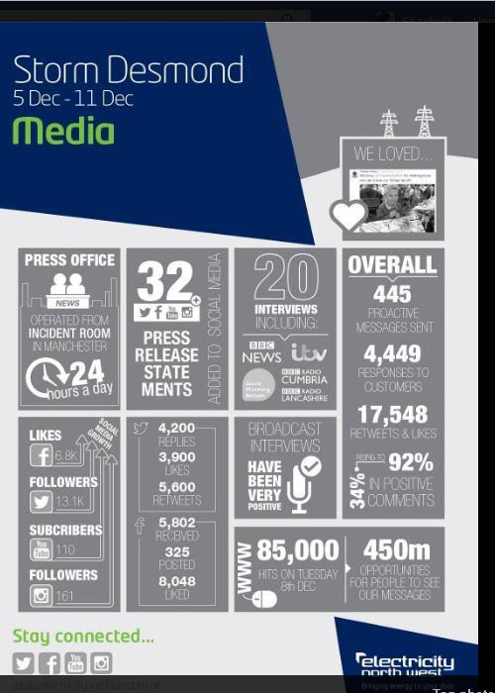

   <http://www.enwl.co.uk/news-and-press/case-studies/storm-desmond-december-2015/2015/12/05/05-12-15-storm-desmond-causes-damage-to-power-network-in-cumbria>

   This image is interesting on a number of fronts, not least because most of the listed modes suppose power - which there was not.