Cutting off and being cut off: reflections on disconnection and the right to electricity
Experiencing a relatively prolonged power cut gave us pause to think about disconnections in other terms, particularly as experienced by those that are ‘fuel poor’ and that get into energy debt. Disconnecting customers from energy supplies has been made progressively harder, with regulatory measures ensuring that energy suppliers follow procedures to try and find ways of managing debt and prohibiting disconnections entirely for ‘vulnerable’ customers over the winter period (there is also a voluntary code of practice that the Big 6 follow to never ‘knowingly’ disconnect vulnerable customers at any time of year). As shown in the figure disconnections consequently fluctuate seasonally and at a generally low level.
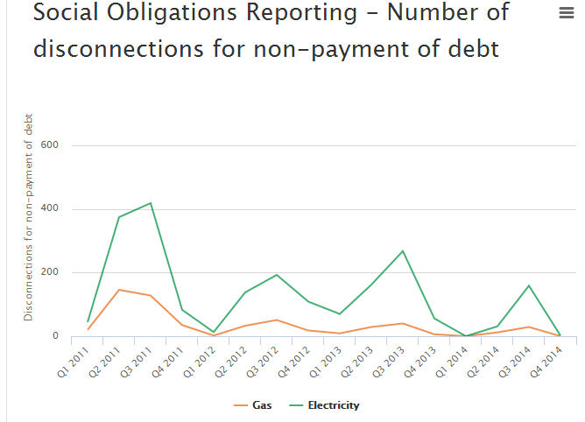
One of the intermediate steps on the way to disconnection is for a customer to have a pre-payment meter fitted, which means if they do not top up the meter sufficiently they will ‘self-disconnect’ for a period until further pre-payments are made. Whilst consumer advocate groups have been keen to highlight the disadvantages and higher energy costs that result from having a prepayment meter, research shows that many households do choose to have a meter installed welcome the fact that this technological arrangement allows them to control the amount they spend on energy rather than being faced with a bill for an unpredictable amount at the end of the month. The number of households paying for their energy through prepayment meters is rising every year, with 300,000 electricity prepayment meters installed in 2014 (OFGEM social reporting 2015).
Source Ofgem https://www.ofgem.gov.uk/about-us/how-we-work/working-consumers/supplier-performance-social-obligations
Both forced disconnection and self-disconnection through not ‘topping up’ the meter are clearly different from experiencing an unplanned and sudden City-wide power cut. The system-wide effects are not experienced, electricity is still flowing outside of the home. Unlike a power cut, there is at least some degree of expectation that power will be lost from a known point in time onwards, and some sense of how long that might be for. Indeed we could speculate that those households ‘used’ to the power going off more regularly would have been more resilient than others when the Lancaster-wide power cut happened, more used to coping, adapting and living at home without normal electricity flows. However such speculation is in danger of normalising and consequently submerging the impacts and consequences of being disconnected, through whatever circumstances.
Recent work (Middlemiss and Gillard 2015) on the lived experience of struggling to afford energy has highlighted the importance of social relationships in balancing finances and accessing essential energy services. For example, going to a relative or friends' house to do washing or cooking/eating has been seen as a way of coping when money is not available to spend on energy. In the Lancaster power cut, with reconnection to electricity taking place haphazardly across the city, the importance of social relations in enabling the reproduction of well-being - being able to cook food for instance or keeping warm - was also evident. As others have discussed in their writing, during the power cut people gathered together where electricity had been reconnected or other energy sources could be used for cooking and keeping warm, such as wood burners or gas stoves. But as is the case for those disconnected in other ways, these social relationships were uneven in their density and strength, some could mobilise them whilst others could not. And importantly such differentiated patterns of social isolation are not independent of indicators of vulnerability to the consequences of losing power (in whatever terms).
It is instructive therefore to have gone through a short period where ‘electricity was not available to power the technologies integral to social practices that constitute the reproduction of everyday well-being in contemporary society’. Electricity has become now an essential ingredient of so many aspects of everyday life and the sustaining of a minimum level of well-being (in a UK context) that arguably it should really be ‘available to all’, not just in terms of access (infrastructure) but also flow (use). Realising demand at a minimum level should therefore be an ongoing right independent of affordability. Water is treated so, disconnection of households from the water supply is now strictly prohibited. Electricity has also evidently become so integral to basic safety, to health, to communication and to learning - particularly in households that are powered by electricity alone – that there is real case for its presence to be guaranteed, and to be still flowing apart from at times of breakdown and crisis. The forthcoming world of smart meter technology can limit how much consumption is possible in real time by a household, meaning that instead of disconnection (or self disconnection) a minimum level of electricity can be supplied and, if necessary, no more. A moral question we would argue, with an available technological solution.

Gordon Walker and Rose Chard

